# I3 Team Report

## Reflection – Filipe Lagrenade and Isaac Ellis

| Project Status |
| --- |

For the first sprint of the semester, it has started off slowly due to a few of the team members having outside commitments. This means that we were unable to get all the tickets which we wanted to complete for this sprint.

We did manage to complete the initial setup of the Vue-Electron client of the student and unit coordinator clients. On the backend we have created flyway migrations to initialise our database, created a spring boot project, connected our spring project via an ORM to the database and integrated Keycloak IAM with spring security.

This means that we did not get a functioning product for the end of this sprint, but we do have most of the framework there to have one ready by next sprint. We are confident that we will be able to complete the backlog tickets as well as next sprint’s tickets by the end of next sprint.

## Plan for Next Sprint – Filipe Lagrenade

For the next sprint we will focus in the first half of the first week on completing the outstanding tickets. We will then have a meeting to create and allocate tickets which will allow us to have a product at the end of the sprint. This will allow us to catch up. We will also be better with taking meeting minutes.

## Burndown Charts – Filipe Lagrenade

Below are 2 burndown charts. The first one is based on time completed/remaining (based on estimations from planning poker) and the second one is based on the number of tasks completed. As stated in the reflection above, these show that we are behind schedule for the project.

## Toggl Report – Filipe Lagrenade

Below is a report generated from Toggl for the last 3 weeks.

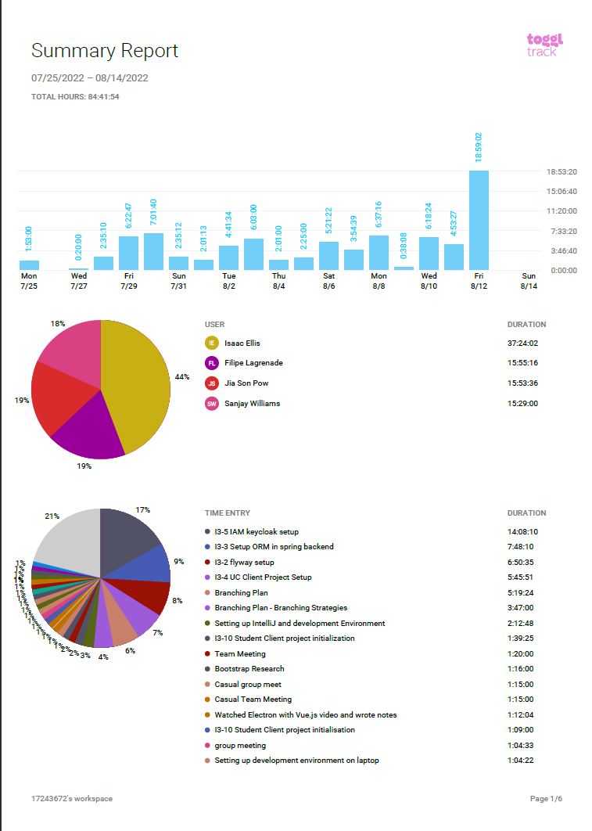

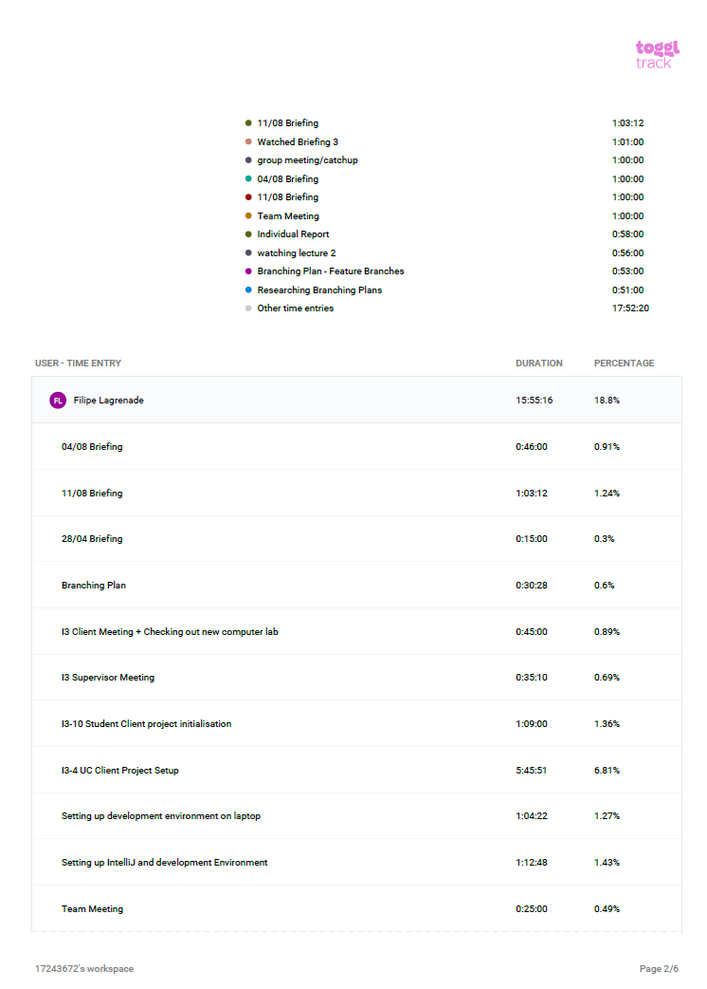

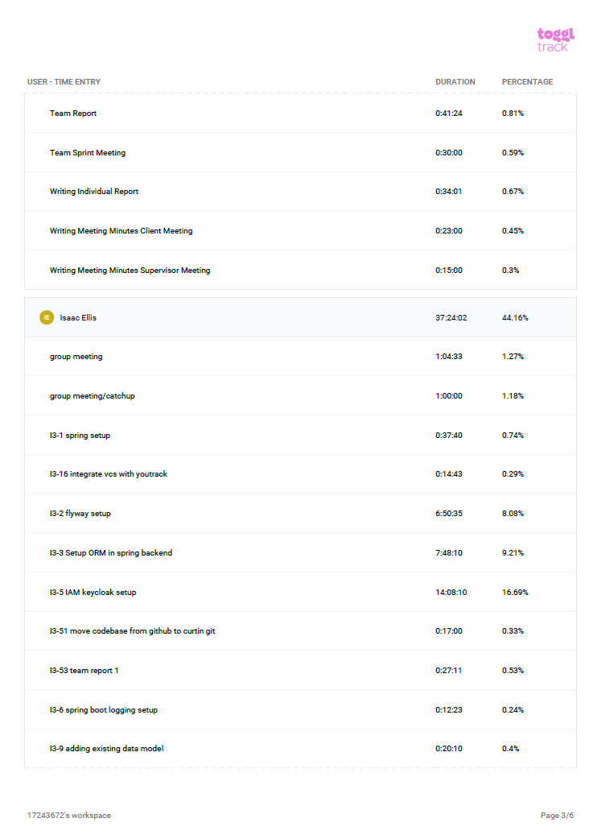

## 

## 

## 

## Tickets completed – Filipe Lagrenade

| Not Started | In Progress | Completed |
| --- | --- | --- |
| I3-13 Spring role-based security | I3-11 Student Client Routing | I3-1 Spring Boot Setup |
| I3-50 Create data for database | I3-54 Team Report 1 | I3-9 Add existing data package to backend |
| I3-52 CSS Framework Setup for UC and Student Client | I3-7 UC Client Basic Page Routing | I3-10 Student client project initialisation |
|  | I3-49 Add PMD to project | I3-2 Flyway setup |
|  |  | I3-53 Branching Plan |
|  |  | I3-3 Setup ORM in spring backend |
|  |  | I3-6 Springboot logging setup |
|  |  | I3-4 UC Client Project Setup |
|  |  | I3-51 Move Codebase from GitHub to bitbucket |
|  |  | I3-5 IAM Keycloak setup |
|  |  | I3-16 Integrate vcs with youtrack |

## Attribution of Work – Filipe Lagrenade

| Ticket | Team Member |
| --- | --- |
| I3-1 Spring Boot Setup | Isaac Ellis |
| I3-9 Add existing data package to backend | Isaac Ellis |
| I3-10 Student client project initialisation | Filipe Lagrenade, Jia Son Pow |
| I3-2 Flyway setup | Isaac Ellis |
| I3-53 Branching Plan | Isaac Ellis, Jia Son Pow, Sanjay Williams, Filipe Lagrenade |
| I3-3 Setup ORM in spring backend | Isaac Ellis |
| I3-6 Spring boot logging setup | Isaac Ellis |
| I3-4 UC Client Project Setup | Filipe Lagrenade |
| I3-51 Move Codebase from GitHub to bitbucket | Isaac Ellis |
| I3-5 IAM Keycloak setup | Isaac Ellis |
| I3-16 Integrate vcs with youtrack | Isaac Ellis |

## Repository – Filipe Lagrenade

Below is a link to the bitbucket repository.

<https://bitbucket.org/isaacellis1/i3-super-lab/src/master/>

## Meeting Minutes - Filipe Lagrenade

# **I3 Client Meeting**

## **Meeting Minutes**

Date of meeting – 05/08/2022

Start time – 4:00PM

End time – 4:25PM

| Present: | Filipe, Isaac, Sanjay, Jay, Hannes |
| --- | --- |
| Absentees: |  |
| Next meeting: | TBD |

1. Announcements

-

2. Discussion

· May not be able to track which students are sitting at what computer

· The computers on a super lab launch windows and then launches linux on a VDI

· This may change the functionality of the question asking feature

· Hannes also mentioned that it would be beneficial to check out the super lab to get an understanding

· May have to set up some way to test the product as we may not be able to install it on the super lab computers yet

# **I3 Supervisor Meeting**

## **Meeting Minutes**

Date of meeting – 28/07/2022

Start time – 4:00PM

End time – 4:35PM

| Present: | Filipe, Isaac, Sanjay, Jay, Arlen |
| --- | --- |
| Absentees: |  |
| Next meeting: | TBD |

1. Announcements

-

2. Discussion

· Arlen mentioned it would be good to discuss with Hannes’ about anything we should be aware about for the super lab now that it has finished/almost finished construction

· Also mentioned that meeting with Hannes would be beneficial to see if any of their needs have changed

· Discussed with Arlen to setup the bitbucket repository

· Also set up with Arlen access to YouTrack (Ticket tracking system)

·